Per Open Meeting Law requirements, an in-person meeting of the Metro-North Railroad Commuter Council (MNRCC) was convened in publicly accessible locations at:
420 Lexington Ave New York, NY and 940 Rose Ave, Bethesda, MD 20852*
at noon on Thursday, July 18, 2024; the public and members unable to attend were present via Zoom.

Member Attendance

Randolph Glucksman (Chair) Present
Walter Zullig (Vice-Chair) Present
Francena Amparo Absent
Richard Cataggio Present – virtual
Francis T. Corcoran Absent
Michael Stanton Present
Rosalind Clay-Carter Present – virtual*

Staff Attendance

Lisa Daglian (Executive Director) Present
Brian Fritch ( Associate Director) Present
Kara Gurl (Planning & Adv. Manager) Absent
Jack Connors (Research & Comm. Assoc.) Present
Jessica Spezio (Admin. Asst.) Present

Non-member Attendance

Name Affiliation

Richard Tjoa Prospective MNRCC Member
Matty Buchys Hyland Concerned citizen

Approval of July 18, 2024 Agenda
Approval of May 16, 2024 Agenda
Approval of April 18, 2024 Minutes

Chair’s and Board Report:

Over the weekend of June 8-9, work crews replaced the first Section of the Park Ave. Viaduct. A time-lapse video showing the operation is available at https://www.youtube.com/watch?v=V6GmRhFydH4

The following weekend, three sections were replaced. As you ride south of the Harlem-125th St. Station, you can’t help to notice the construction barriers and overhead cranes that are stationed nearby.

Metro-North reported that June 16th (Father’s Day), had the best Sunday ridership since the pandemic.

At the June 24th Joint Railroad Committee Meeting, the Long Island Rail Road announced that it was piloting an app that customers could use to report the cleanliness, or uncleanliness, of onboard and station restrooms. I asked if Metro-North would have a similar program, and the answer was yes, by late-July or early August.

Later, at the Capital Program Committee, an update was given about the order for SC-42AC Dual mode locomotives which will replace the current fleet of 31 P-32 Dual Mode Genesis locomotives. These were delivered between 1995-2001 and rebuilt 2012-2015.

The photo below of #401, was taken at the Siemens plant in Sacramento, California.
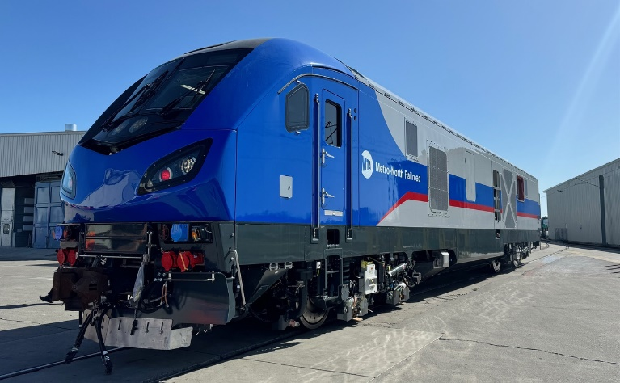

The 33-unit order, without the included options, will deliver 27 for Metro-North and 6 for CT DOT. Two units have already been completed and are undergoing a six-month test at the US Department of Transportation’s Transportation Technology Center in Pueblo, Colorado. Upon completion of this testing, later this year they will be delivered to Metro-North for additional testing and employee training.

In the past month, numerous severe storms have caused service delays due to downed trees, etc. on both sides of the Hudson.

Effective July 1, NJ Transit increased fares on all its transit services by 15%. West-of-Hudson riders on the Port Jervis and Pascack Valley Lines saw the price of their tickets to NY Penn Station increase, but not those traveling to Hoboken. It’s a complicated arrangement where certain fares can only be raised by the MTA following public hearings.

Citing the example above, a monthly ticket from Spring Valley via Secaucus Jct. to NY Penn Station which had been $307, now costs $325. Since the opening of Secaucus Jct. in 2003, Pascack Valley Line fares had usually matched or were within a few dollars of the Hudson Line’s Zone 5 (Croton-Harmon to Tarrytown), but that is certainly not the case now. Since the 2023 MTA fare increase that ticket now costs $299.75.

Here are the key points regarding the “Pause” of Congestion Pricing:
1. There is concern that the pause of Congestion Pricing will disrupt the environmental assessment work that has been done.
2. The group discussed the need for the Governor to announce the un-pause date before December 1st to avoid major disruptions to the process.
3. There is a risk that the pause could be extended or changed at the federal level, which would also impact the plans.
4. They emphasized the importance of keeping the conversation about Congestion Pricing alive and continuing to work with advocacy partners and elected officials on this issue.
5. They noted that Congestion Pricing often polls poorly before implementation but is well-received after it is in place, as seen in other cities like London and Stockholm.

Mike raised that Congestion Pricing was passed in 2019 for the 2020-2024 Capital Plan, but as 2024 nears its end, there have been no discussions about the 2025-2029 plan. He also mentioned that the actual spending under the current plan has fallen short, even before accounting for congestion pricing. The key question is where the Governor and Legislature stand on planning for the next five years.

Lisa said Congestion Pricing was intended for the 2020-2024 plan, but there is confusion around how the budget aligns with spending. She emphasized the need for better education for the public and legislators on how capital budgets work and how they're created. While Congestion Pricing is seen as a solution to fill the current budget gap and address issues like air quality and traffic, she stressed the importance of finding sustainable, reliable funding not only for the next Capital Program but for future Capital Plans as well.

Executive Director Update: By Lisa Daglian

Ongoing Advocacy Efforts:
- Lisa and the staff are focused on continuing the pressure and conversations around Congestion Pricing, working closely with advocacy partners and elected officials.
- They are looking at ways to highlight the facts and fictions surrounding Congestion Pricing, particularly in the areas of job creation and economic development.
- They are also working to keep the concerns and issues of riders at the forefront of the conversation on Congestion Pricing and the Capital Plan, as something happens every day related to aging infrastructure and lack of new projects.

Legislative Priorities:
- Lisa mentioned that Jack is looking at the next legislative calendar to bring forward the "Rider Rep Act” and the "FARES Act,” as well as other legislative priorities raised last year.
- They are also looking at expanding the Fair Fares program to suburban areas with economic need, such as parts of Long Island and Westchester.

Funding Challenges:
- Lisa discussed the growing hole in the MTA's budget due to the delay in Congestion Pricing implementation, which is resulting in over $50 million in lost revenue per day.
- She emphasized the need for sustainable, reliable funding sources, not just for the current capital plan, but for the future as well.
- The group discussed the importance of better educating themselves and others on the budget process and the challenges of spending a capital budget.

Social Media Update: By Jack Connors

- To start, the railroad received several requests to bring back quiet cars
- A rider reached out to MNR flagging that the door to the track 2 platform at Garrison was locked, restricting access to the platform to a single “slow elevator.” The railroad replied in 24 minutes and said they’d contacted station staff.
- Several riders stated their frustrations with a hot car that had no AC.
- Another rider encountered “absolutely disgusting” bathrooms on a 9:02 train from Stamford to GCT, hopefully this is something that QR codes in the bathroom can help prevent in the future as was discussed during the last Joint committee meeting.
- Another rider complained about the high cost of transferring from the LIRR to Metro-North to the LIRR. The railroad pointed them towards the Combo Ticket, which allows such transfers for a flat fee of $8.
- Finally, there have been several complaints about passengers taking up extra seats both with their bodies and their luggage.

Old Business:

Field Trip Planning:

- The group discussed the date for the next field trip, initially considering August 15th but then settling on August 14th.

New Business:

Disability Pride Month and ADA Anniversary:

- Matty wished everyone a happy Disability Pride Month and acknowledged the 34th anniversary of the Americans with Disabilities Act.

- Lisa announced that Kara will be recognized as an MTA accessibility champion at an upcoming ceremony on Monday.

Action Items:

None

Meeting recording: https://www.youtube.com/watch?v=SHHTVAHoTNw

The meeting was adjourned at 1:30 PM.

Respectfully submitted,
Lisa Daglian
Executive Director

