Per Open Meeting Law requirements, an in-person meeting of the Metro-North Railroad Commuter Council (MNRCC) was convened in publicly accessible locations at:
420 Lexington Ave, New York, NY, 6 Dartmouth Rd, Highland Mills, NY* and at 445 Hamilton Ave. White Plains, NY 10601** at 12:00pm on Thursday May 21, 2026. The public and members unable to attend were present via Zoom.

Member Attendance

Randolph Glucksman (Chair) Present
Walter Zullig (Vice-Chair) Present
Francena Amparo Present
Richard Cataggio Present*
Francis T. Corcoran Present**
Michael Stanton Present
Rosalind Clay-Carter Present
Richard Tjoa Present

Staff Attendance

Lisa Daglian (Executive Director) Present
Brian Fritsch (Associate Director) Present
Kara Gurl (Planning & Adv. Manager) Present
Jessica Spezio (Admin. Asst.) Present
Henry Mei Present
Benjamin Ross Absent

Non-member Attendance

Name Affiliation

Andy Buder Metro-North

Approval of Agenda May 21, 2026
Approval of Minutes April 23, 2026

Chair’s and Board Report:

MNR President Justin Vonashek presented lots of good news at the April 27 Joint Railroad Committee Meeting. The 6.2 million rides that were provided in March were 87.2% of March 2019 ridership, and average daily ridership is up 7.6% vs. 2025 to 199,739.

Annual ridership from 2019 -2025:
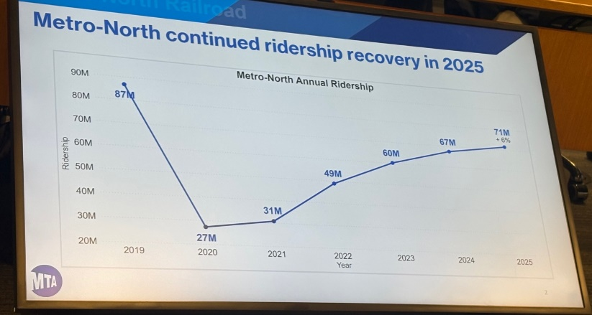

March On-Time-Performance was 97.5%, and ridership was strong for the Yankees Opening Day Weekend.

There was good news on the safety front, with the rolling 12-month customer injury rate falling to 1.44 per one million riders. The rolling average for employee lost time due to injury was 1.94 per 200,000 working hours.

I’ve included this slide as it shows that three of the five stations shown in New York City have seen large ridership gains and support PCAC’s expansion of City Ticket.
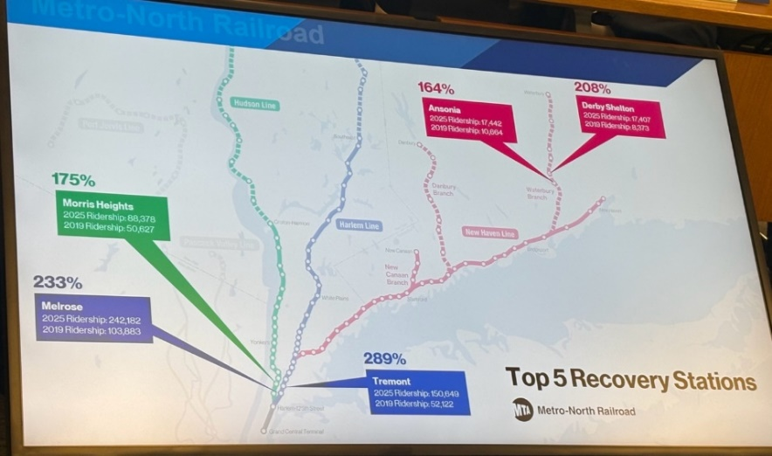

At Grand Central Terminal, an off-hours platform lighting project pilot has been completed and will be expanded to reduce energy use and costs. Also helping to save energy are the new Siemens (dual-mode) Charger locomotives. Nine of the 33 engines ordered have been delivered, and on a typical day five to six are in revenue service. Please note that these engines can operate over the entire third-rail network, whereas the older P-32’s are generally restricted to electric operation in GCT and the Park Ave. Tunnel.

Weekend service on the Haverstraw-Ossining Ferry will operate for a third year between May 23 and October 31, 2026. There will be hourly service between 11:23 AM and 9:10 PM on weekends, however there will be no service on Memorial Day or Labor Day. Since Independence Day is a Saturday, service will operate. In Rockland County, Transport of Rockland buses will run a free shuttle between the Palisades Center Mall and the Haverstraw Ferry Terminal between 8 AM and 10 PM.
Executive Director Update: By Lisa Daglian
- Reported continued progress in the state budget process, noting that key transportation and MTA-related items are still being negotiated in Albany even after the main budget is passed.
- Provided an update on legislative items:
  - RIDER Act: Would change how vacancies on PCAC’s councils are filled to avoid long-term vacancies and improve geographic representation; appears to have some momentum.
  - Rider Representation Act: Would establish voting rider representatives on the MTA Board; unlikely to move this year and expected to be revisited next year.
  - Noted a shift in involvement from MTA leadership, which is now more engaged in the makeup of the MTA board.
- Discussed fare policy priorities, including:
  - Support for the One City One Fare Act and policy concepts (more uniform fares for commuter rail within NYC). This may gain momentum during the MTA’s next fare change process next year.
  - Wins from last year include allowing seniors and disabled riders to use discounts at all times, and expanding discounted youth (“mid-kid”) fares.
- Gave an overview of Fair Fares advocacy:
  - Pushing for automatic enrollment for eligible New Yorkers who already receive other benefits.
  - Argued for raising eligibility to 300% FPL (currently 150% FPL) so that low-wage workers who do not qualify today can benefit.
  - Pushing for fully free fares for people making up to 150% FPL.
  - Emphasized that Fair Fares is funded by the City, and that expanding it could increase ridership without harming MTA finances.
- On commuter rail and Fair Fares, Lisa noted growing interest in extending Fair Fares-style discounts to commuter rail trips within NYC, but said this would require additional funding from the city or state.
- Reported that on the city side, there is positive movement on bus policy:
  - The MTA and NYC are preparing a joint Bus Action Plan report.
  - The administration is more engaged on bus improvements, and the group’s previous BRT work has helped secure a seat at the table.

Social Media Update: By Kara Gurl

- It’s been a quieter month for Metro-North compared to the LIRR, with their ongoing strike and contract negotiations.
- There is still blowback and confusion over fare changes—less specifically about the ten trip this month, but more generally about how it’s impossible to buy tickets in advance and how inflexible the two minute refund window is. In one case, a student shared that they accidentally purchased two one-way tickets and tried to cancel or get a refund for the second, and they were unable to do so.
- Confusion about whether the senior and disabled fare is truly exempt from the late activation surcharge—some riders are getting a warning when activating their ticket.

Old Business:

- Continued advocacy on Fair Fares, related state/city legislation, and the RIDER Act (board vacancies/representation).
- Ongoing concerns about eticket rules (short validity, two minute refund window, advance purchase limits) and the need for better conductor training on the LIRR–Metro-North connecting Combo Ticket.

New Business:

- Discussed the proposal to repurpose the Newburgh–Beacon ferry facilities, including potential transfer or use of the MTA-owned site by local governments; agreed further outreach to local proponents is needed.

Action Items: None

Meeting recording: https://www.youtube.com/watch?v=_TUvV-yQNtg

The meeting adjourned at 1:30 PM.

Respectfully submitted,
Lisa Daglian
Executive Director

